SOLENOID VALVE

INTRODUCTION

An electronically controlled valve to control the flow of liquid and gases is known as a solenoid valve. These valves are used to dose, close, distribute or mix the flow of liquids and gases in a pipe. With endless applications, solenoid valves are the most commonly used component for liquid and gas circuits.

The electronic control is managed by a solenoid, which is an electric coil with a movable ferromagnetic core at its center, called a plunger. When the plunger is in its rest position, it is closed. However, when an electric current is passed through the coil, a magnetic field is created, which exerts a force on the plunger. This magnetic field pulls the plunger towards the centre of the coil. As a result, the orifice opens.

There are four types of solenoid valves:

**1. Direct Acting Valves**

In a direct acting solenoid valve, a coil magnetically opens the valve in a direct action, lifting the shaft and the seat of the valve without depending on outside pressure.

**2. Pilot-Operated Valves**

In pilot operated valves, the plunger opens up the pilot opening while built-up pressure causes the valve to open and close.

Although piloted valves require less electrical energy to operate, they usually need to maintain full power in order to remain in an open state, and they perform at a slower rate than direct acting solenoids. Direct acting solenoid valves only need full power when opening the valve, as they can hold their open position even when operating on low power.

**3. Two-Way Valves**

Each of the two ports on a two-way valve is alternately used to permit flow as well as close it off. A two-way valve can be specified to be either “normally open" or “normally closed” in its operation. With a normally open valve, the valve remains open until some type of current is applied to close the valve. Suspension of the electrical power causes the valve to automatically reopen to its normal state. A normally closed solenoid valve is the most common, working in the opposite fashion, remaining closed until a power source causes it to open.

Few examples of 2 Way valve solenoids:

### The EH30 Series

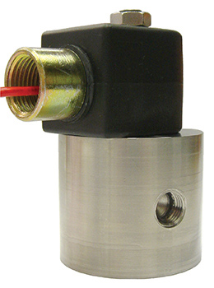 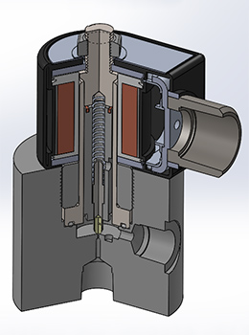 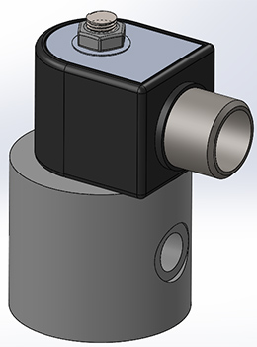

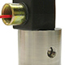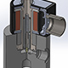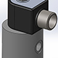

**Features:**   
  
The EH30 is great for a wide range of pressures and many different fluids and gases. This direct acting valve offers a solution to a variety of applications to control the flow of high pressure air, water, hydrogen, nitrogen and other gases or light liquids compatible with materials of construction. Suitable for cryogenic applications, this low flow, high pressure valve packages great versatility in a compact design for pressures up to 10,000 PSIG. No minimum pressure is required for opening, and it will not “burp” due to any rapid spikes in inlet pressure. Both the Normally Closed and Normally Open versions can be universally mounted, as a standard. They both may be mounted in any orientation. **Filters are recommended for all applications.**

### **The EH70 Series**

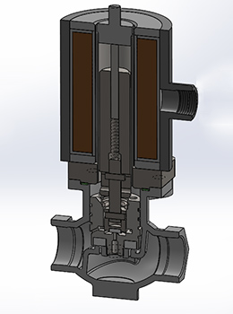 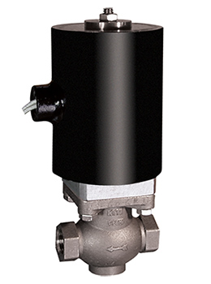 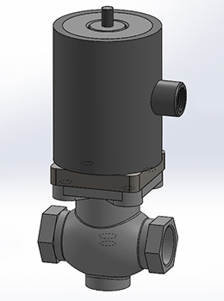

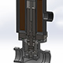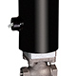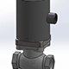

**Features:**   
  
The powerful, full port EH70 is great for a wide range of flow rates, temperatures, and a wide range of fluids and gases. It has become a popular choice for cryogenic conditions and applications that need to control higher pressures in a hazardous location. This pilot assisted, direct operated valve utilizes a [UL/CSA certified](http://clarkcooper.com/specscerts/certs-etl.html) enclosure for all hazardous locations, is available in larger pipe sizes (up to 2”) and for inlet pressures up to 1,500 PSIG. The versatile EH70 requires no minimum pressure for opening, and for up through to the 1" sizes, can be mounted in any orientation. (Normally Closed and Normally Open). This valve is CRN certified with all Canadian provinces. Other uses of the EH70 include controlling the flow of deionized water, condensate, ammonias, vegetable oils, fuel oils, hydrogen, cryogenics, flammable liquids and gases and other gases or liquids compatible with materials of construction.**Filters are recommended for all applications.**

**4. Three-Way Valves**

Three-way valves come with three ports. These are commonly used when alternate and exhaustive pressure are required for operation, as with a coffee machine or dishwasher.

### **ER Valves(Three way)**

**A three-way valve can have three different types of operation:**

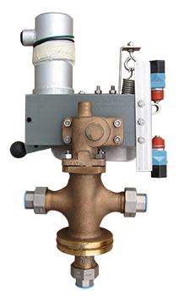

* The first type of three-way valve is a **diverting valve**, which has one inlet and two outlets. Flow goes from the single inlet to the selected outlet and can only go to one outlet at a time.
* The second type is a **selecting three-way valve**, which has two inlets and one outlet. Depending on whether the valve is activated or not, flow goes from the selected inlet to the single outlet. Flow can only come from one inlet at a time.
* The third type has a supply port, outlet port, and vent port. When the supply is open and the vent is closed, flow travels from the supply to the outlet. When the supply is closed and the vent is open, flow travels from the outlet to the vent. These are available with the supply normally open or the supply normally closed.

**5. Four-Way Valves**

These valves can have four or more port connections. Four-way valves are commonly used with a dual acting cylinder or actuator. In this version, half of the port connections supply pressure, and the remaining connections provideexhaust pressure. You can specify these valves to be either normally closed, normally open or universal.